St. Leonard 11th Annual Turkey Trot Sponsorship Opportunities

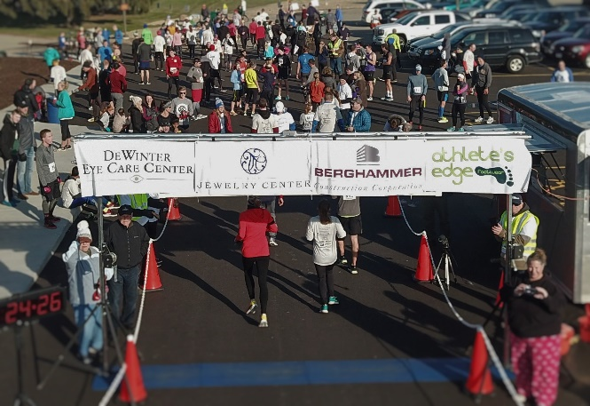
BRONZE SPONSOR $200
- Printed company name on T-shirts
- Company name on 2023 registration form

SILVER SPONSOR $400
- Logo on T-shirts
- Logo on 2023 registration form

GOLD SPONSOR $800
- Large logo placed higher on T-shirts
- Logo on 2023 registration form
- Sign with company logo to be placed in finish line area

PLATINUM SPONSOR - $1000+
- All gold sponsorship
- Your banner prominently displayed at water stations
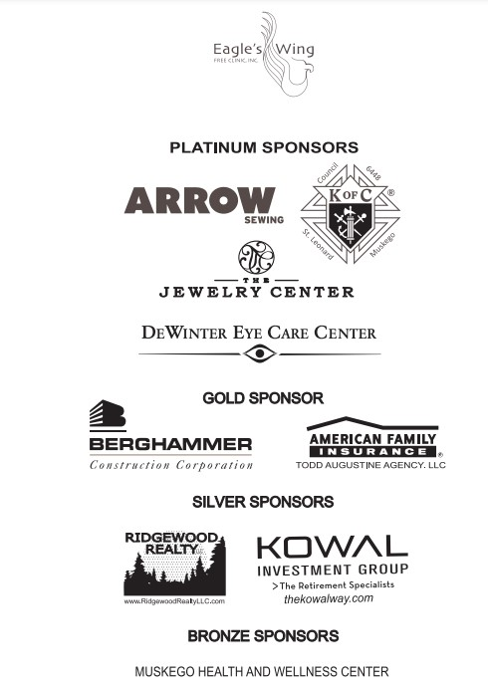

All proceeds from this year’s run will benefit Life’s Connection Community Health and Education Center with locations in Mukwonago and Waukesha.

Please complete and return with payment by October 30th
Checks payable to St. Leonard Congregation
Include Turkey Trot Sponsor in memo

Mail checks to:
St. Leonard Turkey Trot
W173 S7743 Westwood Drive
Muskego, WI 53150
Contact: Allen Jorn
Phone: (262)-408-3538
Email: allenjorn@sbcglobal.net

Company Name

Contact Name Sponsor Amount $

Email Phone
Thank you

